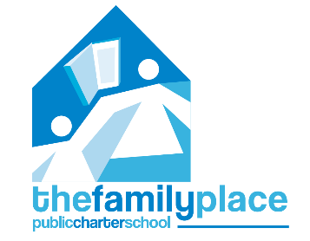

The Family Place Public Charter School
Board of Trustees meeting schedule
2022-2023

August 16th, 2022
October 18th, 2022
December 13th, 2022*
February 21st, 2023
April 18th, 2023**
June 20th, 2023

The Family Place Public Charter School Board of Trustees will meet on the third Tuesday of every other month (unless otherwise noted). This is no fewer than what is stated in TFPPCS’s bylaws, which require at least four meetings per year.

* The December meeting will be on the 2nd Tuesday.
** The 2023-2024 budget will be discussed and approved at the April meeting.

